TASK ONE

**Business Name : Brewed Awakening**

*A Sip of Something Real*

At **Brewed Awakening**, we believe that a cup of coffee is more than just a drink—it’s a moment to pause, reflect, and connect. Located in the heart of the community, our coffee shop serves only the finest locally sourced, organic coffee beans, roasted to perfection. Our mission is simple: to create a cozy, welcoming space where friends can gather, ideas can brew, and every cup helps nurture a sustainable future. We’re passionate about reducing our environmental impact, which is why we use eco-friendly practices, from compostable cups to zero-waste initiatives. Whether you’re here for a morning pick-me-up, an afternoon chat, or a quiet moment of inspiration, Brewed Awakening is your home away from home.

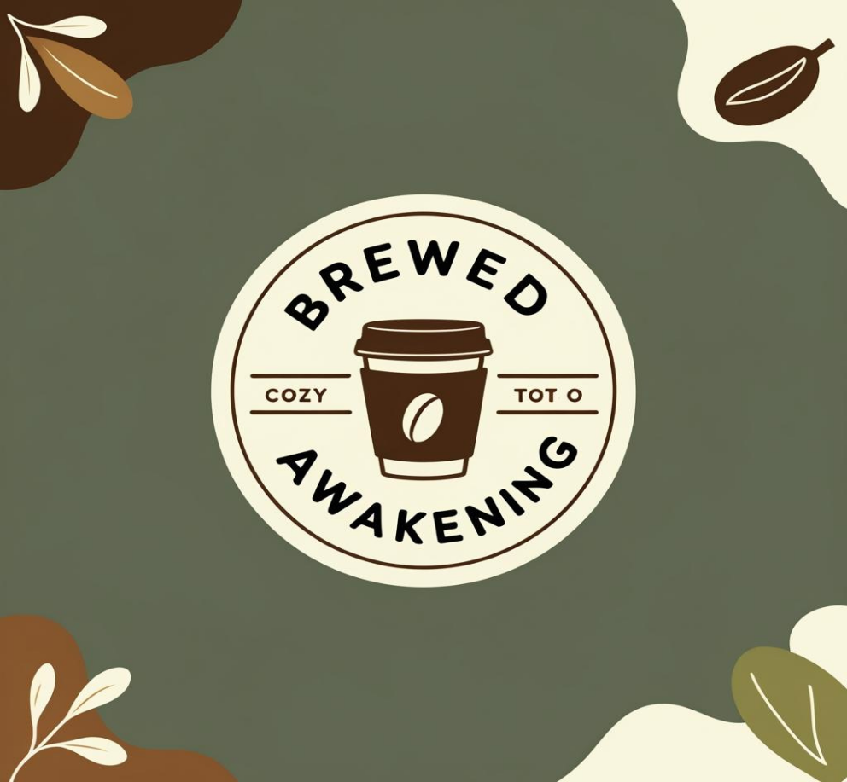

**LOGO**

**Promotional Post for Opening/Grand Launch**

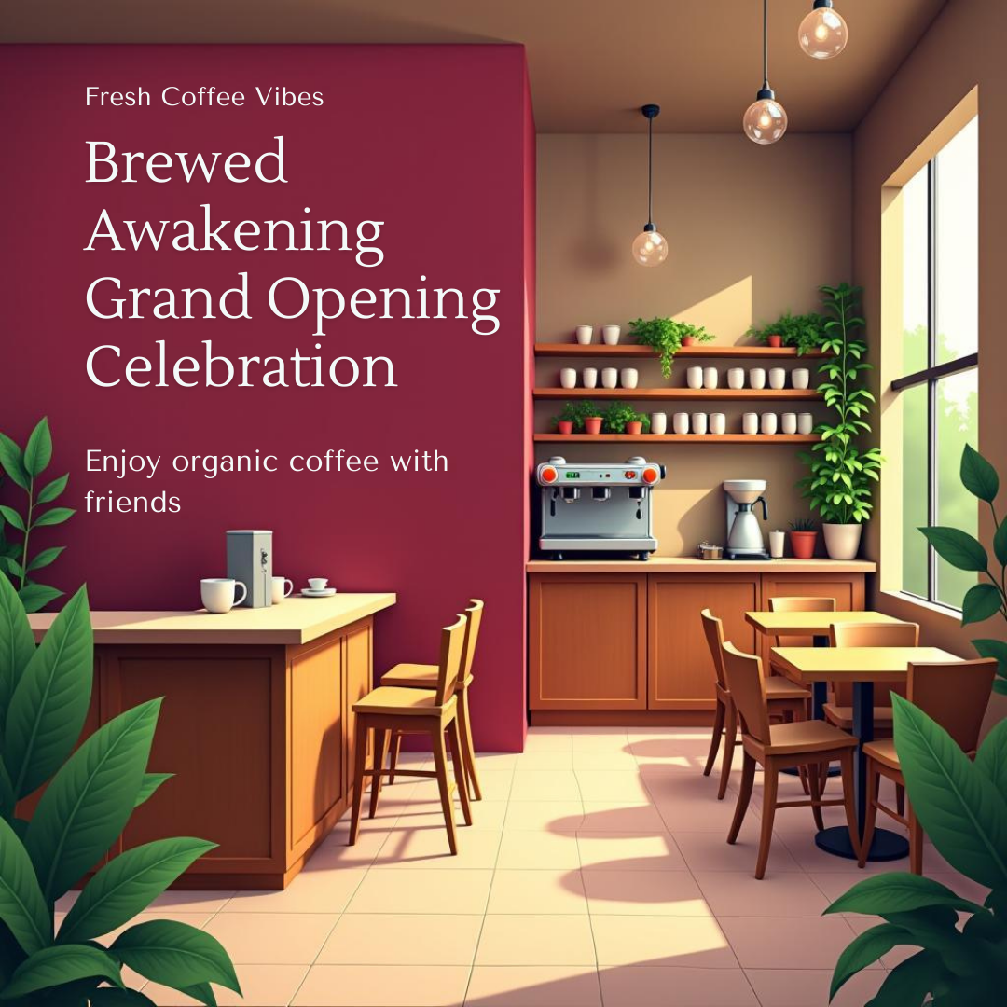

**Social Media Post Highlighting Sustainability**

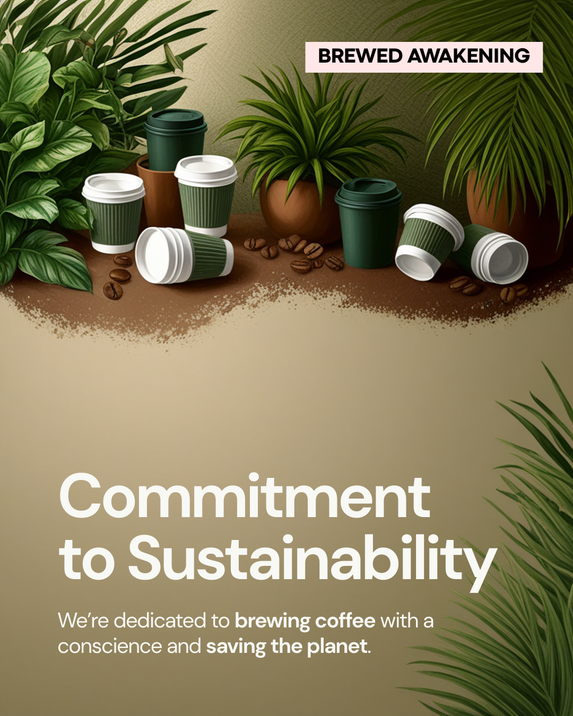

### ****Engaging Ads for Brewed Awakening:****

**1. "Your Perfect Brew Awaits!"**

**Take a Sip. Feel the Difference.**  
Brewed Awakening serves more than just coffee—we serve connections, comfort, and sustainability in every cup. Sourced locally, brewed with love. Come find your favorite blend today!

**2. "More Than Coffee, It’s a Community"**

Need a break? Let Brewed Awakening be your escape. Enjoy organic, locally-sourced coffee in a cozy, eco-friendly space where everyone is welcome. Join us for a brew, stay for the vibe.

**3. "Wake Up to Real Flavor!"**

At Brewed Awakening, every cup is a fresh start. Taste the difference with organic, locally-sourced beans that support both the planet and our local farmers. Your morning routine just got an upgrade!

### ****Blog Post Idea: "The Heartbeat of Brewed Awakening: Connecting Through Coffee"****

**Title: “From Bean to Cup: Why Coffee Means More at Brewed Awakening”**

There’s something special about the ritual of brewing a cup of coffee—it’s more than just a morning habit, it’s a moment to pause, to center yourself, and to connect with the world around you. At Brewed Awakening, we believe that every sip should nourish not just your body, but your soul and your community.

From the moment you step inside our doors, the air is filled with the comforting aromas of freshly ground organic coffee beans. But it’s not just the coffee that makes our space unique—it’s the people. Whether you’re here to catch up with friends, focus on your work, or simply enjoy a moment of peace, we’re here to provide a space that feels like home.

Our commitment to local, organic coffee is at the core of everything we do. We source our beans from farmers who share our values—ones who prioritize ethical, sustainable practices that preserve the environment. That’s why every cup at Brewed Awakening isn’t just about great flavor; it’s about making a positive impact on our world.

But it’s not just about sustainability—it’s about connection. At Brewed Awakening, we’re more than just a coffee shop; we’re a community hub. A place where everyone belongs, and every conversation matters. Whether you’re meeting up with an old friend or striking up a new one, the cozy atmosphere of our shop is the perfect backdrop for making memories.

So next time you need a pick-me-up, come see us. Let’s share a cup, slow down, and connect. Because at Brewed Awakening, we believe that the best moments happen when we take time to truly savor them.

### ****Product Descriptions:****

**1. Brewed Awakening Organic Espresso**

A bold yet smooth experience in every shot. Our Organic Espresso blend is crafted from the finest locally-sourced beans, offering a rich, robust flavor that wakes you up without overwhelming the senses. Perfect for your morning espresso, or as the base of your favorite specialty drink. Ethical, sustainable, and utterly satisfying.

**2. Signature Brewed Awakening Blend**

Dive into a cup of pure comfort with our Signature Brewed Awakening Blend. Crafted from organic, small-batch beans sourced from local farms, this medium-roast coffee delivers a balanced flavor profile with hints of chocolate and a touch of toasted nuts. It’s your perfect companion for a cozy morning, a productive afternoon, or anytime you need a moment to unwind.

**3. Cold Brew - Organic & Refreshing**

Refresh your day with our Organic Cold Brew. Slow-steeped for 24 hours, this brew is rich in flavor yet smooth and mellow—never bitter. It’s the perfect balance of boldness and refreshment, made from the finest organic beans. Cool down while staying eco-friendly, sip by satisfying sip.

**4. Vegan Chocolate Truffles**

Pair your coffee with something sweet—our handmade Vegan Chocolate Truffles. Made with organic cocoa and crafted with love, these rich, velvety treats are a perfect match for your Brewed Awakening coffee. Enjoy a guilt-free indulgence that supports sustainable practices and local artisans.

**EMAIL:**

**Subject: Elevate Your Brand with AI-Driven Design—Here’s How**

Dear sir/madam,

I hope you’re doing well! I’m reaching out to introduce a powerful way we can help elevate your brand’s presence and set you apart in the market—**AI-powered branding**.

In today’s fast-paced world, the traditional design process can feel slow, expensive, and often inconsistent. What if you could get high-quality, custom branding assets in days, not weeks? And what if those assets were specifically tailored to your business goals, scalable across all platforms, and designed to make a lasting impact on your audience?

Here’s how AI-generated branding can make a difference for you:

### **1. Tailored, High-Quality Designs—Faster and More Efficiently**

AI-powered design can analyze your brand’s unique needs and generate personalized assets that reflect your vision. From logos to social media templates, everything is crafted to match your brand’s personality—quickly and with a professional touch.

### **2. Consistency Across All Platforms**

Whether you’re looking to create a new logo, update your website, or design cohesive social media assets, AI ensures consistency across all your branding materials. This creates a unified, polished brand identity that resonates with your target audience.

### **3. Cost-Effective and Scalable**

With AI, you eliminate the lengthy and expensive back-and-forth with traditional design agencies. Plus, the best part is that the assets are scalable as your business grows. Need new templates or assets? The process is just as easy, cost-effective, and fast.

### **4. Eco-Friendly & Future-Proof**

Our AI technology is powered by data, which means no paper drafts or wasteful processes. The digital nature of our service not only supports sustainability, but it also ensures your brand stays ahead of the curve as digital marketing and online branding become even more essential.

### **Why Choose Us?**

**Efficient & Time-Saving**: No more waiting months for design revisions.

**Affordable**: High-quality branding without the high agency costs.

**Tailored Just for You**: AI adapts to your needs and delivers designs that truly represent your business.

I’d love to show you how this works in action and how we can help your brand stand out with designs that speak to your audience and grow your presence. Would you be open to a quick call or demo?

Looking forward to connecting!

Best regards,  
Paula Aketch  
PLP COMPANY